**Steps of Digital Image Processing:**

**1. Image Acquisition**

* **Definition:** Capturing an image using a sensor (like a camera) and converting it to a digital form.
* **Steps:**
  + Use a camera or scanner to capture the image.
  + Convert the captured image into a digital format using an analog-to-digital converter.

**2. Image Enhancement**

* **Definition:** Improving the visual appearance of an image or making it more suitable for a specific task.
* **Techniques:**
  + Adjusting brightness and contrast.
  + Applying filters to sharpen or smooth the image.
  + Removing noise to make details clearer.

**3. Image Restoration**

* **Definition:** Correcting defects in an image to restore its original appearance.
* **Methods:**
  + Removing blurriness caused by motion or out-of-focus lenses.
  + Fixing damaged parts of the image (like scratches or missing pieces).

**4. Color Image Processing**

* **Definition:** Handling images in color and manipulating them.
* **Processes:**
  + Adjusting color balance and saturation.
  + Converting between color spaces (e.g., RGB to grayscale).

**5. Wavelets and Multi-Resolution Processing**

* **Definition:** Breaking down an image into different levels of detail or resolution.
* **Usage:**
  + Compressing images by focusing on important details.
  + Enhancing specific features at various scales.

**6. Compression**

* **Definition:** Reducing the size of an image file without losing important information.
* **Types:**
  + Lossless compression: No loss of image quality (e.g., PNG).
  + Lossy compression: Some loss of quality but much smaller file size (e.g., JPEG).

**7. Morphological Processing**

* **Definition:** Analyzing and processing shapes within an image.
* **Operations:**
  + Dilation: Expanding shapes in the image.
  + Erosion: Shrinking shapes in the image.
  + Used to remove noise, fill gaps, and separate objects.

**8. Segmentation**

* **Definition:** Dividing an image into meaningful parts or regions.
* **Techniques:**
  + Thresholding: Separating objects based on color or intensity.
  + Edge detection: Finding the boundaries of objects.

**9. Representation and Description**

* **Definition:** Converting segmented regions into a form that a computer can analyze.
* **Steps:**
  + Representation: Choosing how to describe the shapes (e.g., outlines, skeletons).
  + Description: Extracting features like size, shape, and texture.

**10. Object Recognition**

* **Definition:** Identifying objects or patterns in an image.
* **Methods:**
  + Matching features with known patterns.
  + Using machine learning algorithms to recognize and classify objects.

**11. Knowledge Base**

* **Definition:** A database of information used to improve image processing tasks.
* **Components:**
  + Storing known patterns, shapes, and models.
  + Using historical data to make better decisions in image analysis.

# Gray Level Transformation

All Image Processing Techniques focused on gray level transformation as it operates directly on pixels. The gray level image involves 256 levels of gray and in a histogram, horizontal axis spans from 0 to 255, and the vertical axis depends on the number of pixels in the image.

**The simplest formula for image enhancement technique is:**

**s = T * r**

Where T is transformation, r is the value of pixels, s is pixel value before and after processing.

Let,

**r = f(x,y)**

**s = g(x,y)**

'r' and 's' are used to denote gray levels of f and g at(x,y)

There are three types of transformation:

1. Linear
2. Logarithmic
3. Power - law

The overall graph is shown below:

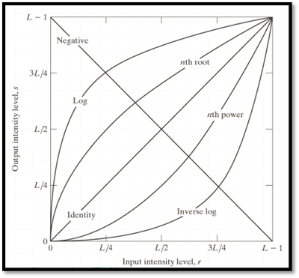

## Linear Transformation

The linear transformation includes identity transformation and negative transformation.

**In identity transformation**, each value of the image is directly mapped to each other values of the output image.

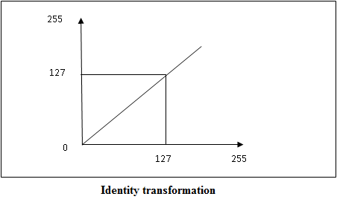

**Negative transformation** is the opposite of identity transformation. Here, each value of the input image is subtracted from L-1 and then it is mapped onto the output image  
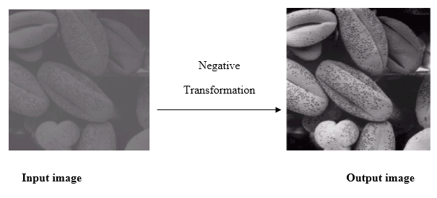

## Logarithmic transformations

Logarithmic transformation is divided into two types:

1. Log transformation
2. Inverse log transformation

The formula for Logarithmic transformation

**s = c log(r + 1)**

Here, s and r are the pixel values for input and output image. And c is constant. In the formula, we can see that 1 is added to each pixel value this is because if pixel intensity is zero in the image then log(0) is infinity so, to have minimum value one is added.

When log transformation is done dark pixels are expanded as compared to higher pixel values. In log transformation higher pixels are compresses.

## Power - Law transformations

Power Law Transformation is of two types of transformation nth power transformation and nth root transformation.

**Formula:**

**s = cr ^ γ**

Here, γ is gamma, by which this transformation is known as gamma transformation.

All display devices have their own gamma correction. That is why images are displayed at different intensity.

These transformations are used for enhancing images.

**For example:**

Gamma of CRT is between 1.8 to 2.5

# Components of Image Processing System

* **Image Sensors:**  
  Image sensors senses the intensity, amplitude, co-ordinates and other features of the images and passes the result to the image processing hardware. It includes the problem domain.
* **Image Processing Hardware:**  
  Image processing hardware is the dedicated hardware that is used to process the instructions obtained from the image sensors. It passes the result to general purpose computer.
* **Computer:**  
  Computer used in the image processing system is the general purpose computer that is used by us in our daily life.
* **Image Processing Software:**  
  Image processing software is the software that includes all the mechanisms and algorithms that are used in image processing system.
* **Mass Storage:**  
  Mass storage stores the pixels of the images during the processing.
* **Hard Copy Device:**  
  Once the image is processed then it is stored in the hard copy device. It can be a pen drive or any external ROM device.
* **Image Display:**  
  It includes the monitor or display screen that displays the processed images.
* **Network:**  
  Network is the connection of all the above elements of the image processing system.

### ****Histogram Equalization****

**Histogram Equalization** is a technique used to enhance the contrast of an image by redistributing the intensity levels. It is particularly useful for improving the visibility of features in images with poor contrast. Here's a breakdown of the process:

#### ****Concept****

* **Purpose**: To adjust the image contrast so that the intensity distribution is spread more uniformly across the entire range of possible intensity values.
* **Goal**: To improve the overall contrast of an image, making features more distinguishable.

# Spatial Filtering and its Types

**Spatial Filtering** technique is used directly on pixels of an image. Mask is usually considered to be added in size so that it has specific center pixel. This mask is moved on the image such that the center of the mask traverses all image pixels.

### ****Smoothing Spatial Filter****

Smoothing filter is used for blurring and noise reduction in the image. Blurring is pre-processing steps for removal of small details and Noise Reduction is accomplished by blurring.

Types of Smoothing Spatial Filter

**1.** Linear Filter (Mean Filter)  
**2.** Order Statistics (Non-linear) filter

These are explained as following below.

1. **Mean Filter:** Linear spatial filter is simply the average of the pixels contained in the neighborhood of the filter mask. The idea is replacing the value of every pixel in an image by the average of the grey levels in the neighborhood define by the filter mask. Below are the types of mean filter:
   * **Averaging filter:** It is used in reduction of the detail in image. All coefficients are equal.
   * **Weighted averaging filter:** In this, pixels are multiplied by different coefficients. Center pixel is multiplied by a higher value than average filter.
2. **Order Statistics Filter:** It is based on the ordering the pixels contained in the image area encompassed by the filter. It replaces the value of the center pixel with the value determined by the ranking result. Edges are better preserved in this filtering. Below are the types of order statistics filter:
   * **Minimum filter:** 0th percentile filter is the minimum filter. The value of the center is replaced by the smallest value in the window.
   * **Maximum filter:** 100th percentile filter is the maximum filter. The value of the center is replaced by the largest value in the window.
   * **Median filter:** Each pixel in the image is considered. First neighboring pixels are sorted and original values of the pixel is replaced by the median of the list.

### ****Sharpening Spatial Filter****

It is also known as derivative filter. The purpose of the sharpening spatial filter is just the opposite of the smoothing spatial filter. Its main focus in on the removal of blurring and highlight the edges. It is based on the first and second order derivative.

# Frequency Domain Filters and its Types

**Frequency Domain Filters** are used for smoothing and sharpening of image by removal of high or low frequency components. Sometimes it is possible of removal of very high and very low frequency. Frequency domain filters are different from spatial domain filters as it basically focuses on the frequency of the images. It is basically done for two basic operation i.e., Smoothing and Sharpening.

These are of 3 types:

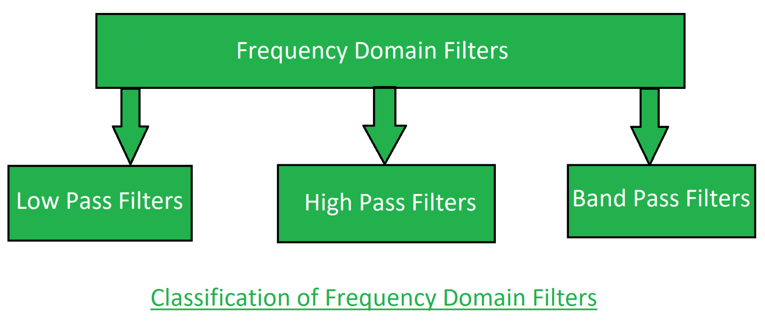

**1. Low pass filter:**  
Low pass filter removes the high frequency components that means it keeps low frequency components. It is used for smoothing the image. It is used to smoothen the image by attenuating high frequency components and preserving low frequency components.

**2. High pass filter:**  
High pass filter removes the low frequency components that means it keeps high frequency components. It is used for sharpening the image. It is used to sharpen the image by attenuating low frequency components and preserving high frequency components.

**3. Band pass filter:**  
Band pass filter removes the very low frequency and very high frequency components that means it keeps the moderate range band of frequencies. Band pass filtering is used to enhance edges while reducing the noise at the same time.